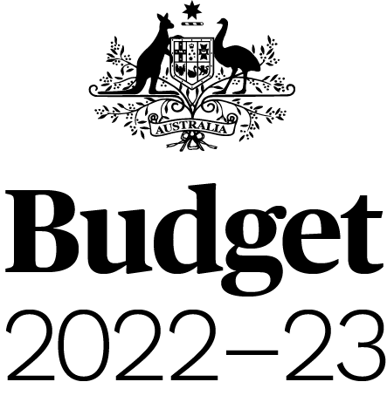

Budget Strategy and Outlook
Budget Paper No. 1
2022–23

Circulated by
The Honourable Josh Frydenberg MP
Treasurer of the Commonwealth of Australia
and
Senator the Hon Simon Birmingham
Minister for Finance of the Commonwealth of Australia

For the information of honourable members
on the occasion of the Budget 2022-23
29 March 2022

© Commonwealth of Australia 2022
ISSN 0728 7194 (print); 1326 4133 (online)
This publication is available for your use under a Creative Commons BY Attribution 3.0 Australia licence, with the exception of the Commonwealth Coat of Arms, third-party content and where otherwise stated. The full licence terms are available from http://creativecommons.org/licenses/by/3.0/au/legalcode.

Use of Commonwealth of Australia material under a Creative Commons BY Attribution 3.0 Australia licence requires you to attribute the work (but not in any way that suggests that the Commonwealth of Australia endorses you or your use of the work).
Commonwealth of Australia material used ‘as supplied’.
Provided you have not modified or transformed Commonwealth of Australia material in any way including, for example, by changing the Commonwealth of Australia text; calculating percentage changes; graphing or charting data; or deriving new statistics from published statistics — then the Commonwealth of Australia prefers the following attribution:
Source: The Commonwealth of Australia.
Derivative material
If you have modified or transformed Commonwealth of Australia material, or derived new material from those of the Commonwealth of Australia in any way, then the Commonwealth of Australia prefers the following attribution:
Based on Commonwealth of Australia data.
Use of the Coat of Arms
The terms under which the Coat of Arms can be used are set out on
the Department of the Prime Minister and Cabinet website (see www.pmc.gov.au/
government/commonwealth-coat-arms).
Other uses
Enquiries regarding this licence and any other use of this document are welcome at:
Manager
Media Unit
The Treasury
Langton Crescent
Parkes ACT 2600
Email: media@treasury.gov.au
Internet
A copy of this document is available on the central Budget website at: www.budget.gov.au.
Printed by CanPrint Communications Pty Ltd.

Notes
- The following definitions are used in this Budget Paper:
  - ‘real’ means adjusted for the effect of inflation;
  - real growth in expenses and payments is calculated using the Consumer Price Index (CPI) as the deflator;
  - the Budget year refers to 2022-23, while the forward years refer to 2023-24, 2024-25 and 2025-26; and
  - one billion is equal to one thousand million.
- Figures in tables and generally in the text have been rounded. Discrepancies in tables between totals and sums of components are due to rounding.
  - Estimates under $100,000 are rounded to the nearest thousand.
  - Estimates $100,000 and over are generally rounded to the nearest tenth of a million.
  - Estimates midway between rounding points are rounded up.
  - The percentage changes in statistical tables are calculated using unrounded data.
- For the budget balance, a negative sign indicates a deficit while no sign indicates a surplus.
- The following notations are used:
- | nil
na | not applicable (unless otherwise specified)
$m | millions of dollars
$b | billions of dollars
nfp | not for publication
(e) | estimates (unless otherwise specified)
(p) | projections (unless otherwise specified)
NEC/nec | not elsewhere classified
- The Australian Capital Territory and the Northern Territory are referred to as ‘the territories’. References to the ‘states’ or ‘each state’ include the territories.
The following abbreviations are used for the names of the states, where appropriate:
NSW | New South Wales
VIC | Victoria
QLD | Queensland
WA | Western Australia
SA | South Australia
TAS | Tasmania
ACT | Australian Capital Territory
NT | Northern Territory
- In this paper the term ‘Commonwealth’ refers to the Commonwealth of Australia. The term is used when referring to the legal entity of the Commonwealth of Australia.
The term ‘Australian Government’ is used when referring to the Government and the decisions and activities made by the Government on behalf of the Commonwealth of Australia.
Budget Paper No. 1, Budget Strategy and Outlook 2022-23, is one of a series of Budget Papers that provides information to supplement the Budget Speech. A full list of the series is printed on the inside cover of this paper.

Contents
Statement 1: Budget Overview 5
Economic and Fiscal Outlook 5
Budget priorities 9
Statement 2: Economic Outlook 31
Overview 31
Outlook for the international economy 38
Outlook for the domestic economy 45
Medium-term projections 66
Statement 3: Fiscal Strategy and Outlook 73
Overview 73
Economic and Fiscal Strategy 75
Fiscal outlook 79
The Government’s balance sheet 97
Other fiscal aggregates 102
Statement 4: Revenue 111
Overview 111
Variations in receipts estimates 116
Variations in revenue estimates 128
Appendix A: Tax Benchmarks and Variations Statement 131
Statement 5: Expenses and Net Capital Investment 139
Overview 139
Estimated expenses by function 141
General government sector expenses 145
General government net capital investment 175
Appendix A: Expense by function and sub-function 180
Statement 6: Debt Statement 185
Overview 185
Australian Government Securities issuance 185
Estimates of AGS on issue 186
Treasury Notes 191
Non-resident holdings of AGS on issue 192
Estimates and projections of net debt 193
Interest on AGS 195
Climate spending 198
Statement 7: Forecasting Performance and Sensitivity Analysis 203
Overview 203
Assessing historical forecasting performance 204
Assessing current forecasts through confidence interval analysis 208
Assessing current forecasts through sensitivity analysis 213
Statement 8: Statement of Risks 223
Risks to the Budget – Overview 223
Agriculture, Water and the Environment 232
Attorney-General’s 233
Defence 234
Education, Skills and Employment 236
Finance 237
Foreign Affairs and Trade 241
Health 242
Home Affairs 247
Industry, Science, Energy and Resources 249
Infrastructure, Transport, Regional Development and Communications 254
Prime Minister and Cabinet 261
Social Services 263
Treasury 264
Veterans’ Affairs 271
Government loans 271
Statement 9: Australian Government Budget Financial Statements 289
Notes to the general government sector financial statements 305
Appendix A: Financial reporting standards and budget concepts 321
AASB 1049 Conceptual framework 321
Appendix B: Assets and Liabilities 329
The Australian Government’s major assets and liabilities 329
Statement 10: Historical Australian Government Data 337
Data sources 337
Comparability of data across years 337
Revisions to previously published data 339

