Introduction and Guide to Budget Paper No. 4
The purpose of Budget Paper No. 4 is to provide a whole-of-government view of estimated resourcing managed in the Budget year and previous year by agencies (which are non-corporate Commonwealth entities, corporate Commonwealth entities and Commonwealth companies) in the General Government Sector (GGS). The resources include financial resources, staff resources, expenses and net capital investment.
The Budget Papers do not authorise appropriations or impose legal obligations on the Commonwealth.
Budget Paper No. 4 contains three main parts and an appendix with tables of information as follows:
Part 1 Agency Financial Resourcing
1.1 Agency Resourcing Table
1.2 Special Appropriations Table
1.3 Special Accounts Table
Part 2 Staffing of Agencies
Part 3 Expenses and Net Capital Investment
3.1 Departmental Expenses Table
3.2 Net Capital Investment Table
Appendix A: Agency Outcome Statements
The Agency Financial Resourcing tables present appropriation information by portfolio and then by agency. Estimated resourcing is presented on a cash basis for both the Budget year and previous year (which is printed below the Budget year in italics, or to the left of the Budget year in a separate column). The tables include agencies, Outcomes, special appropriations and special accounts, and estimates of annual appropriations and external revenue, as well as staffing for the 2022–23 and 2023–24 years.
Estimates contained in the Budget Papers incorporate assumptions and judgements based on the best information available at the time of publication.

Transfer of resourcing between agencies
Agencies may, over the course of a financial year, transfer amounts of resourcing to other agencies, as a result of restructuring, legislative changes, Executive decisions and machinery of government changes enacted by amendments to the Administrative Arrangements Order (AAO). Resourcing, at the date of change and afterwards, is reflected against the agency that gains the resources. Resourcing prior to the date of change is reflected against the agency that formerly managed the resources.

Supply Bills and annual Appropriation Bills
Throughout Budget Paper No. 4, references to annual appropriations and Appropriation Bills for 2023–24 should be taken to include the relevant Appropriation Bills.
Annual appropriation amounts appearing for 2022–23 include the relevant Supply Acts and Appropriation Acts. References to annual appropriation amounts for 2022–23 do not include the Appropriation Bills (Nos. 3 and 4) 2022–2023, as they had not been enacted at the time of publication.

Guide to Resourcing Tables
Linkages between tables and amounts presented in Budget Paper No. 4 are illustrated in Figures 1 to 4. A consolidated view of financial resources to be managed by agencies is presented in the Agency Resourcing Table. Amounts in the Agency Resourcing Table can be matched with information in the:
- annual Appropriation Bills
- Special Appropriations Table
- Special Accounts Table.
Figures 1 and 2 show how amounts in the Agency Resourcing Table can be matched with amounts in the annual Appropriations Bills. The Figures also highlight amounts in these Bills for non-operating expenditure and for payments to the States, Territories and local governments.
Figures 3 and 4 show how amounts in the Agency Resourcing Table can be matched with amounts in the Special Appropriations Table and the Special Accounts Table.

Figure 1: Example of the Agency Resourcing Table and Appropriation Bill (No. 1)
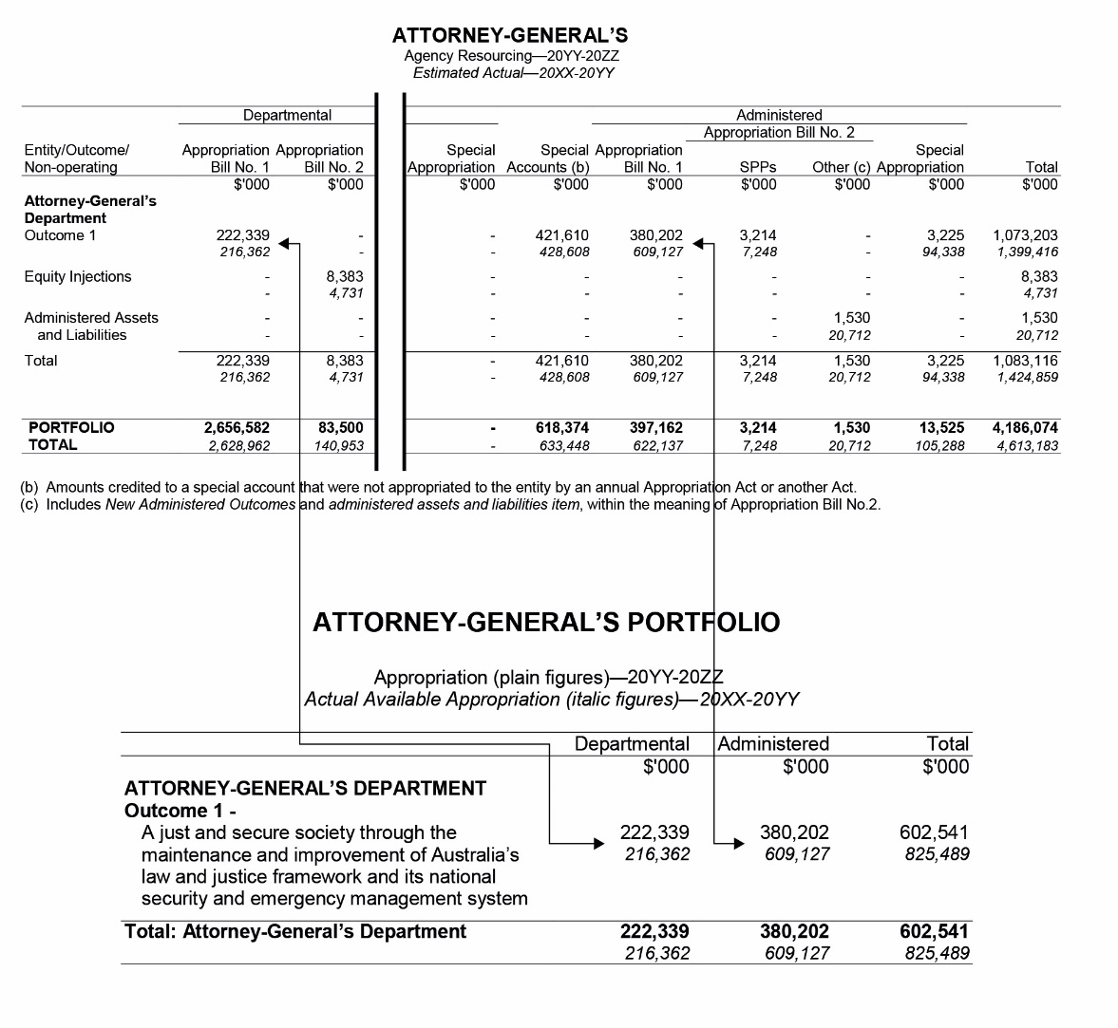

Figure 2: Example of the Agency Resourcing Table and Appropriation Bill (No. 2)
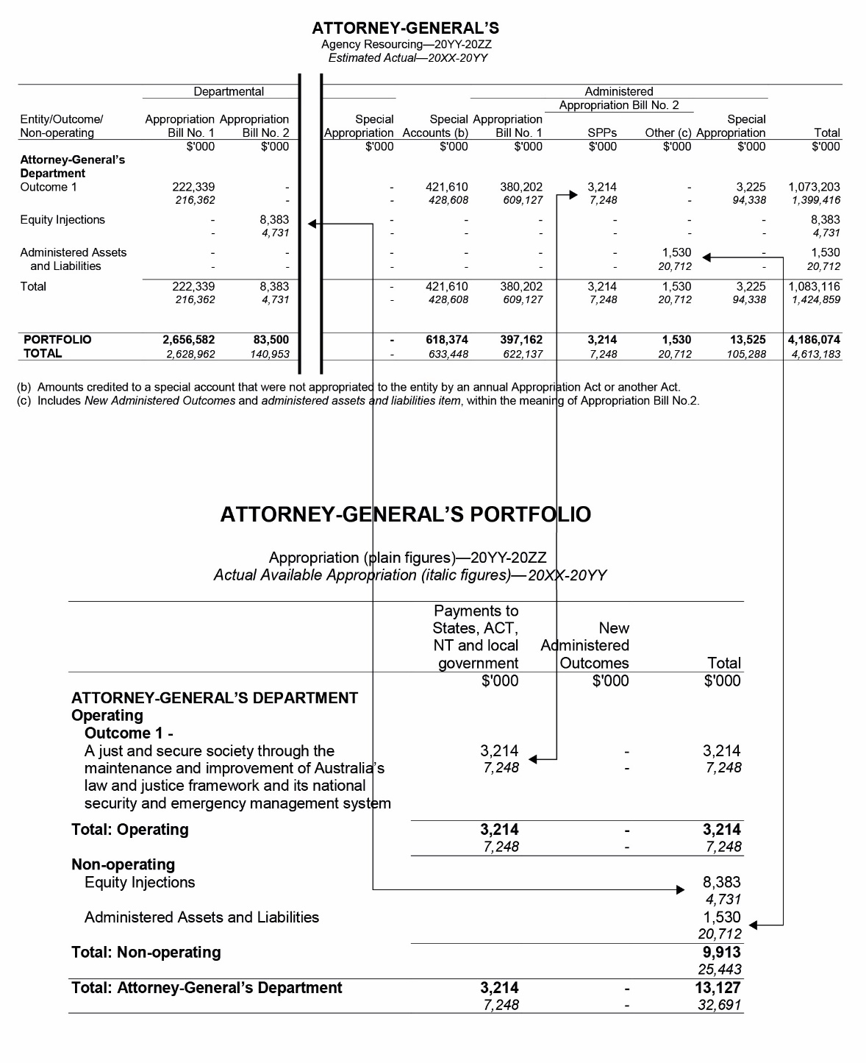

Figure 3: Example of the Agency Resourcing Table and Special Appropriations Table
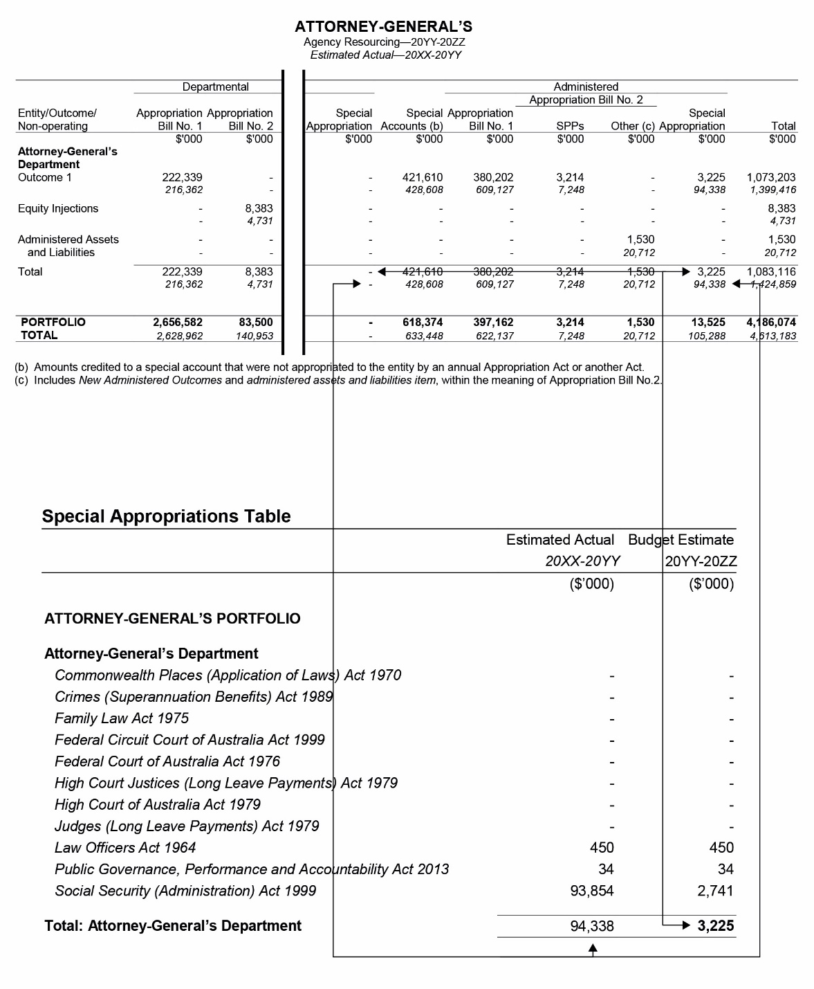

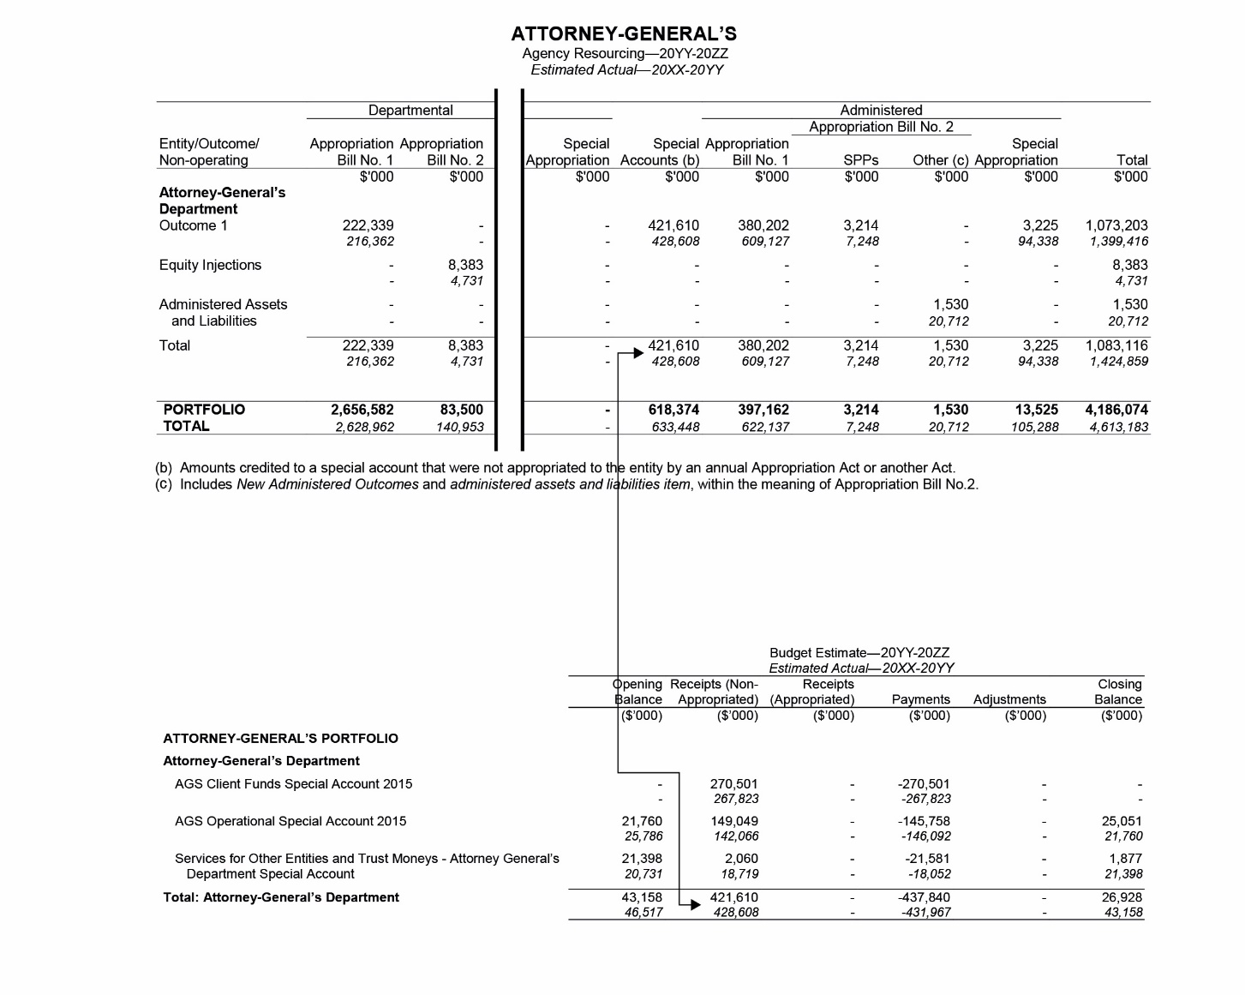
Figure 4: Example of the Agency Resourcing Table and Special Accounts Table

The Appropriation Bills are: Appropriation Bill (No. 1) 2023–2024, Appropriation Bill (No. 2) 2023–2024 and Appropriation (Parliamentary Departments) Bill (No. 1) 2023–2024.
The Supply Acts are: Supply Act (No. 1) 2022–2023, Supply Act (No. 2) 2022–2023, Supply Act (No. 3) 2022–2023, Supply Act (No. 4) 2022–2023, Supply (Parliamentary Departments) Act (No. 1) 2022–2023 and Supply (Parliamentary Departments) Act (No. 2) 2022–2023
The Appropriation Acts are: Appropriation Act (No. 1) 2023–2023, Appropriation Act (No. 2) 2022–2023 and Appropriation (Parliamentary Departments) Act (No. 1) 2022–2023.

