Delivering a better deal for small businesses

Australian Government Small Business Statement

Driving our economy
Australia’s 2.5 million small businesses are vital to the country’s prosperity. They drive innovation and productivity. Small businesses contribute more than $500 billion to the economy and employ around 5.2 million people. They are also an integral part of their local communities, providing jobs, revenue, services and more, adding to the strength of these communities.
Small business owners work hard. The Government continues to support small businesses through challenges and create the economic conditions for small businesses to invest, innovate and generate new jobs that will benefit Australian communities.
The Government expects economic growth to remain subdued over the forecast period. However, inflation is moderating, real wages are growing again and business investment is expanding. Small businesses have a central role to play in helping Australia seize the opportunities of a stronger economy.

An enduring priority
The Government is committed to improving the operating environment for small businesses and helping them to thrive. The key priorities are:
- easing the pressure on small businesses by streamlining processes to minimise administrative burden and helping them bounce back from challenges
- supporting small businesses to grow by encouraging business entry, growth and dynamism in the small business sector
- levelling the playing field for small businesses by enabling healthy competition and ensuring small businesses get a fair go.

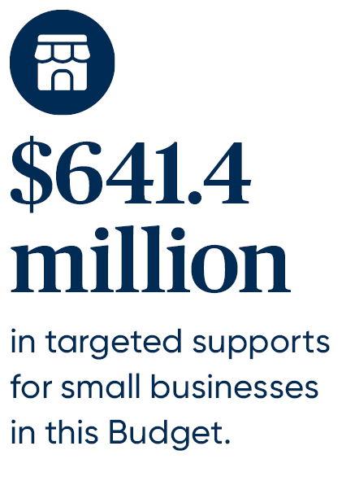

From the Minister
Small businesses matter. A strong small business sector is good for Australia and good for our local communities.
Throughout Australia’s cities, regional towns and rural communities, the needs of small businesses vary.
The Government recognises that some small businesses continue to face challenges, dealing with inflation and the cost of doing business, natural disasters, cyber security threats and worker shortages.
That is why the Government is delivering practical supports to ease the pressure on small businesses. We continue to focus on making it easier to do business, improving regulatory settings and helping small businesses grow in the digital economy.
The Government has listened to small business owners. This Budget delivers a better deal for small businesses and ensures they stay at the heart of our decision-making.

[Signature]
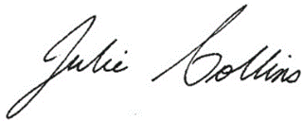
The Hon Julie Collins MP
Minister for Small Business
May 2024


Easing the pressure on small businesses
The Government is making it easier for small businesses to do business, by delivering supports and reforming regulatory settings in a way that considers the burden and costs for small business owners.
These supports are vital for small business owners to prepare for, manage and remain resilient to large shocks, such as natural disasters, as well as the day-to-day stressors of running a small business.

Supporting mental health and financial wellbeing
The Government recognises that small business owners face unique challenges, with their mental health connected to the financial health of their small business.
This Budget invests a further $10.8 million to support the mental health and financial wellbeing of small business owners by:
- extending the NewAccess for Small Business Owners program, which provides tailored, free and confidential mental health support to small business owners
- extending the Small Business Debt Helpline, a national, free and confidential phone-based financial counselling service for small business owners.
‘I’ve not long finished the NewAccess for Small Business Owners program ... We worked through a few different tools and I got into great habits I’m still using now after the sessions have wrapped up … Mental health support can be so costly, and sometimes also come with huge waits, so I was shocked at how quickly I was able to start the program, and the fact that it was free is incredible.’
NewAccess for Small Business Owners participant

Relieving energy bill pressures
The Government is providing direct energy bill relief for small businesses.
- The Energy Bill Relief Fund is providing energy rebates to each of the approximately one million businesses on small customer electricity plans to help cover their electricity bills. This Budget will provide additional energy bill relief of $325 to eligible small businesses.
- The Government is providing $1.8 million to progress regulatory reforms to retail energy markets that will support consumers experiencing hardship and ensure small businesses are on electricity contracts that work better for them.

Improving payment times to small businesses
The Government is investing a further $25.3 million in this Budget to improve payment times to small businesses, on top of the $8.1 million provided in MYEFO 2023–24. This will ensure the Payment Times Reporting Regulator can deliver its expanded functions, which includes naming slow paying businesses, and funding
fit-for-purpose ICT infrastructure.

Saving small businesses time and money
The Government continues to help small businesses save time and money.
- The Government is providing $290 million in cash flow support by extending the $20,000 instant asset write-off. Small businesses with annual turnover of less than $10 million will be able to immediately deduct eligible assets costing less than $20,000 until 30 June 2025.
- $23.3 million will support increased eInvoicing adoption to improve cash flow, disrupt payment redirection scams and boost productivity for small businesses.
- From 1 July 2024, the Government will abolish 457 nuisance tariffs in the largest unilateral tariff reform in two decades. This will simplify Australia’s trade system and cut compliance costs for businesses, including small businesses which are particularly burdened by complexity of the tariff system.
- The Government is investing $288.1 million to deliver and expand the Digital ID system. Once operational, the expanded Digital ID System will lower the administrative burden on small businesses by reducing the amount of ID data they need to store and protect for their customers and their employees.
- The Government will provide $13.2 million over three years in targeted assistance to increase the number of residential builders accredited under the Work Health and Safety Accreditation Scheme.
This builds on the $21.8 million committed in the 2023–24 Budget over the forward estimates to lower the administrative burden for small businesses and reduce the time they spend doing taxes.
The Government is also investing $11 million per year for the ongoing delivery of the business.gov.au website and contact centre. As the Government’s primary information service for the Australian business community, the Single Business Service reduces the time businesses need to spend understanding and navigating government to increase the time they can spend doing business and growing the business.
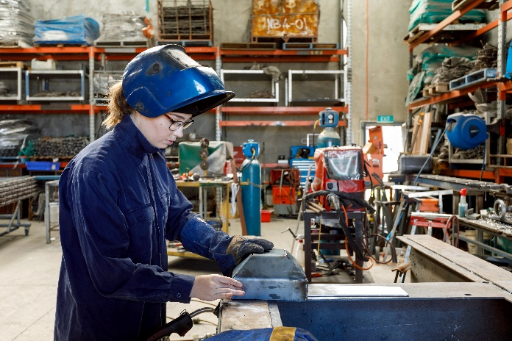

Building cyber resilience
The Government is supporting small businesses to be secure online while they adopt and harness digital opportunities, including through:
- $23.4 million for the Cyber Wardens program to provide free, online training for small business owners and their staff to help drive cultural change and a cyber safe mindset in Australian small businesses
- $11.1 million for the Small Business Cyber Resilience Service to help small businesses build their cyber resilience and provide support when affected by a cyber incident
- $7.2 million for the Cyber Health Check online interactive tool to enable small and medium businesses to self-assess their cyber security maturity.
The Government is also developing a ransomware playbook to provide guidance to businesses and individuals on how to prepare for, respond to and recover from a ransomware or cyber extortion incident.

Balancing small business and employee needs
The Government is making it easier for small businesses to support their employees. This Budget provides:
- $20.5 million to the Fair Work Ombudsman to assist small business employers to comply with workplace laws
- $60 million for the Productivity, Education and Training Fund to support practical activities by employer and worker representatives to boost workplace productivity and engage in tripartite cooperation
- $10 million for Services Australia to provide additional support for small business employers administering the Paid Parental Leave scheme.

Delivering disaster supports
The Government is working with the states and territories to deliver disaster supports for the small business community.
Since the last Budget, the Government has committed to cost-share more than $69 million with the states and territories for clean-up and recovery assistance to support disaster-affected small businesses and not-for-profit organisations following disaster events.

Supporting small businesses to grow
The Government is committed to ensuring small businesses get a fair go so they can enter, compete and innovate in dynamic sectors.

Helping small businesses win business
The Government is helping small businesses compete for and win more Government contracts.
- The Government will invest $183.8 million in defence industry grants to support Australian small and medium businesses. This will include the new Defence Industry Development Grant Program, which will reduce the administrative burden on small and medium businesses and provide greater opportunities for tailored financial support.
- The Buy Australian Plan is opening the door to more government work for more small and medium businesses by simplifying and decoding procurement processes.
- The Government has updated the Commonwealth Procurement Rules to increase significantly the small and medium business participation target and is improving AusTender to make it easier to identify small and medium businesses on government panels.
- The Government is committing $10.9 million to expand support for businesses to export through enhancements for the Go Global Toolkit online platform.

Powering innovation
The Government recognises small businesses as job-creators and innovators and seeks to support them to diversify Australia’s economy and trade. Through investments in manufacturing, clean energy and a workforce trained in new technologies, small businesses will both help build and benefit from a Future Made in Australia. By making ourselves an indispensable part of global net zero supply chains, we can continue to deliver prosperity for generations to come.
Making contributions to supply chains will be a feature of government investment under the Future Made in Australia initiative to bolster local economic activity.
This builds on existing investments to support small businesses to innovate, including:
- $392.4 million through the Industry Growth Program to help start-ups and small businesses in their most challenging development phase to innovate, commercialise their ideas, and grow
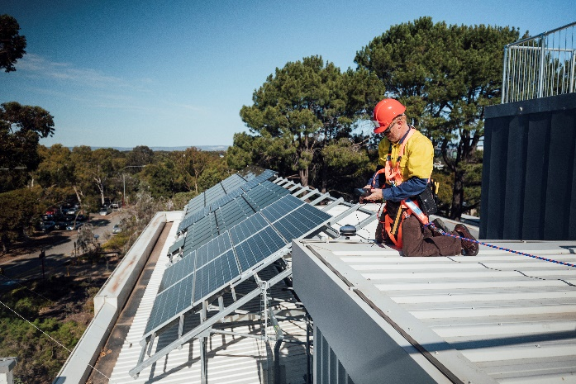
- $18.6 million for Round 2 of the Digital Solutions program to help small businesses adopt digital tools and embrace the opportunities that going online offers.

After arriving in Australia, Khirullah, a skilled painter, was determined to rebuild his career by relaunching his successful overseas painting business. Despite facing challenges due to his limited English proficiency, Khirullah accessed Digital Solutions’ one-to-one advisory services seeking guidance to create a website. The program provided Khirullah with resources in his first language which supported him to create his English language website and set up Facebook and Instagram business accounts to further promote and connect with potential customers.
NSW/ACT Digital Solutions provider
The Government is helping businesses develop and use safe and responsible artificial intelligence (AI).
- The Budget commits $39.9 million to the ‘Safe and Responsible AI’ program. This will maximise the benefits of AI while mitigating risks by progressing guardrails for high-risk AI and priority reviews of existing laws.
- This builds upon existing measures including the National AI Centre, access to a free ‘Introduction to AI’ course through TAFE NSW, the establishment of a Temporary Expert Advisory Group, and developing an AI safety standard.
The Government is supporting small businesses to improve energy efficiency and lower emissions, allowing small business owners to invest in their businesses while building a clean energy future for the nation.
- The Government has invested $62.6 million through the Energy Efficiency Grants for Small and Medium Sized Enterprises program, providing grants of up to $25,000 to businesses to fund a range of energy upgrades, such as replacing inefficient appliances and improving heating systems.

Ensuring the right skills in the right place
The Government is helping small businesses address critical labour and skills shortages.
- The new National Skills Agreement will continue to expand access to the vocational education and training sector, support quality training and implement reforms to address critical skills needs.
- The Government is investing $88.8 million to provide an additional 20,000 fee-free TAFE places in courses relevant to the construction sector. This is on top of the additional 300,000 fee-free TAFE places made available from 2024 to 2026 in areas of priority skills.
- The Government is providing $1.8 million over three years from 2025–26 to support small and medium businesses to access Group Training Organisation (GTO) services for clean energy, manufacturing and construction apprentices. The Government will reimburse GTO fees for up to 800 small and medium businesses.
- The Government is providing $1.8 million to deliver streamlined skills assessments for around 1,900 migrants from comparable countries to work in Australia’s housing construction industry.
- The Government is providing $21.9 million to support social enterprises and employers to engage job seekers through paid employment placements of up to six months. This includes grant funding of $1.5 million over two years to support the certification of an expected 500 Work Integrated Social Enterprises.
The AusIndustry Business Outreach Network, through Regional Managers, provides local support to connect business and industry to Government programs, information, and networks to support growth opportunities.
‘These regional managers know the local business landscape … have an extensive network of Gov & industry contacts ... Simply stated, without them the pathway from ‘Start up’ to ‘Commercialisation’ would be more challenging with [sic] longer timeline, from a taxpayer perspective – great value for money.’
Queensland small business owner

Focusing on First Nations businesses
A key priority for the Government is to improve outcomes and progress towards self-determination for First Nations people through economic development and participation. This includes supporting First Nations businesses, many of which are small businesses, to thrive.
- The Government intends to enhance Indigenous Business Australia’s ability to leverage their capital to invest in First Nations communities and businesses.
- The Government is committed to providing more opportunities for First Nations businesses through procurement and has been consulting on how to strengthen the Commonwealth Indigenous Procurement Policy (IPP) program. Since 2015, the IPP has generated over $9.5 billion in contracts for more than 3,900 Indigenous businesses.
- The Government is scoping a First Nations Economic Partnership with the Coalition of Peaks and other organisations to improve economic outcomes for Indigenous Australians including those operating small businesses.

- The Government’s $2.1 billion investment for remote housing and homelands in the Northern Territory along with other major remote infrastructure measures will create local employment opportunities and support the sustainability of Aboriginal Business Enterprises.

Supporting our care providers
Small businesses are an essential part of the care and support economy.
- The Government is working to finalise an Eighth Community Pharmacy Agreement, supported by up to an additional $3 billion in funding, to deliver cheaper medicines, improve patient health outcomes and secure a strong community pharmacy sector.
- The Government is funding wage rises and workforce initiatives in the aged care sector, helping businesses attract and retain skilled staff.

Supporting veteran-owned businesses
The Government is extending the Supporting Veteran Owned Business grant program through The King’s Trust Australia Enterprise Program. The program provides self-employment support to veterans and their families.

Levelling the playing field for small businesses
The Government is prioritising a fair and equitable operating environment in which small businesses can compete and thrive.

Ensuring confidence in the franchising sector
The Government is creating a fairer playing field in the franchising sector.
The sector, comprising thousands of small businesses, is a key part of the Australian economy. It employs around 520,000 people and contributes more than $135 billion to the Australian economy each year.
In response to the 2023 Schaper Review of the Franchising Code of Conduct, the Government is providing $3 million to remake and improve the Code, promote best practice conduct between franchisors and franchisees and make it easier for small businesses to operate in the sector including through better access to dispute resolution.

Improving access to justice
The Government is providing small businesses with better access to justice.
The Australian Small Business and Family Enterprise Ombudsman (ASBFEO) assists and advocates for small businesses including helping to resolve disputes.
In this Budget, the Government is investing $2.6 million over four years (and $0.7 million per year ongoing) to expand the ASBFEO’s service offering to allow a broader range of unrepresented small businesses, including franchisees, access to low-cost legal advice and assistance to navigate business disputes.

Promoting healthy competition
The Government is boosting competition in key markets and ensuring small businesses benefit from a more level playing field by delivering a broad range of much-needed changes.
- Reviewing and reforming Australia’s competition policy settings to increase productivity, reduce the cost of living and boost wages. The Government’s Competition Review is consulting on the use of non-compete clauses and other restraints in our economy that restrict opportunities for workers to move jobs and limit access to talent for businesses.
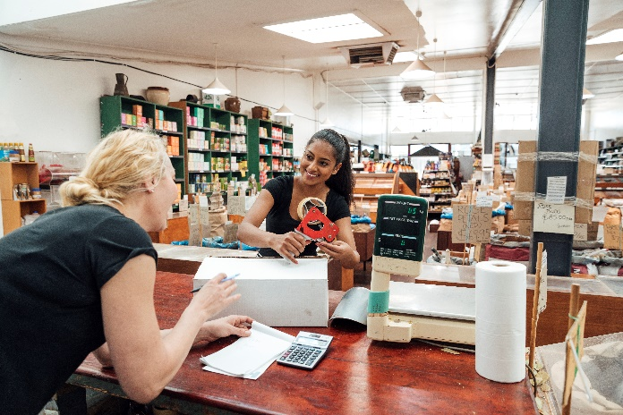
- Introducing a designated complaints function, giving consumer and small business advocates special powers to raise significant and systemic issues for investigation by the Australian Competition and Consumer Commission (ACCC).
- Strengthening unfair contract terms protections for small businesses, including giving courts the power to impose a civil penalty for use of unfair terms in standard form contracts. This helps level the playing field in negotiations between big businesses and small businesses.
- Enforcing the Mandatory Gas Code of Conduct to shield Australian households and businesses from rising domestic gas prices. The Code is ensuring that east coast gas users can contract for gas at reasonable prices, on reasonable terms.
- Reforming Australia’s merger laws. The ACCC will receive stronger powers to detect and stop anti-competitive mergers that hurt consumers and small businesses. Small businesses will also benefit from greater transparency during the ACCC’s merger review process, with more opportunity to engage on mergers that affect them. Under the new system, small businesses will be exempt from paying merger fees.

Backing fairer dealings with supermarkets
The Government is putting downward pressure on the price of essentials for Australians. This includes an inquiry by the ACCC into the supermarket sector, which will deliver its final report by 28 February 2025.
The Government has appointed the Hon Dr Craig Emerson to conduct an independent review of the Food and Grocery Code of Conduct to improve dealings between supermarkets and their suppliers, especially smaller suppliers. The Interim Report recommended the Code be mandatory with heavy penalties for breaches and new protections against retribution. The final report is due by 30 June 2024.

Working across governments for small business
The Government re-established the Small Business Ministers’ Meeting to strengthen connections with the states and territories. Through this forum, the Government is driving a national discussion about small business productivity, regulation and resilience.
At the upcoming Small Business Ministers’ Meeting in June 2024, the Government will explore options for a National Small Business Strategy. Working together with the states and territories, the Government aims to drive a coordinated and cohesive national approach to small business supports and reforms.

