Backing small businesses

Australian Government Small Business Statement

Building on economic momentum
Australia’s 2.6 million small businesses create jobs, deliver services, drive innovation, and are critical to local communities and the nation’s prosperity.
The Australian Government is backing small businesses so they can harness opportunities as economic conditions improve. In this Parliamentary term, the Government has committed more than $2 billion in targeted supports for small businesses. In addition, the Government expects around 1.5 million sole traders to benefit from the Government’s tax cuts for every taxpayer.

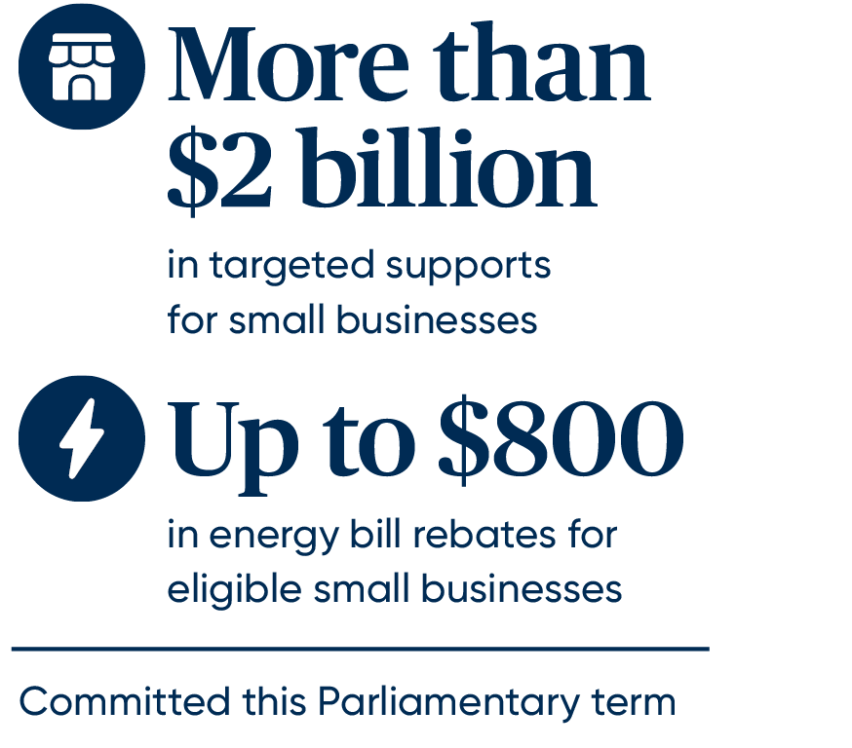

Supporting small businesses
The Government is committed to improving the operating environment for small businesses to help them thrive.
That is why the Government developed the landmark National Small Business Strategy with the states and territories. Acknowledging that each level of government has a role to play, it expresses our collective commitment to work together to better support small businesses across our nation, with a focus on:
- easing the pressure on small businesses
- supporting small businesses to grow
- levelling the playing field.

Easing the pressure on small businesses
The Government is making it easier for small businesses to do business by cutting red tape and helping them bounce back from challenges. This Budget includes:
- extending energy bill relief to 31 December 2025, with around one million eligible small businesses able to access up to $800 of energy bill relief since the 2023–‍24 Budget
- promoting prompt 20-day payment times for contractors and subcontractors in the construction industry for work completed for Government Business Enterprises undertaking major construction activity, such as the NBN Co Ltd and Western Sydney Airport (WSA) Co Ltd
- supporting the hospitality sector and alcohol producers by pausing indexation on draught beer excise and excise equivalent customs duty rates and by increasing support available under the existing Excise remission scheme for manufacturers of alcoholic beverages and Wine Equalisation Tax Producer rebate, estimated to decrease receipts by $165.0 million over five years from 2024–‍25

- providing $18.0 million for creditor assistance payments to support eligible businesses affected by the Whyalla Steelworks administration.
This builds on the Government’s previously announced commitments, including:
- providing significant cash flow support to small businesses through extensions to the instant asset write-off
- $25.9 million to support the mental health and financial wellbeing of small business owners through the NewAccess for Small Business Owners program and the Small Business Debt Helpline
- the $33.4 million investment to improve payment times for small businesses, including $25.3 million in the 2024–25 Budget to support the overhauled Payment Times Reporting Scheme and enhance the Regulator’s ability to deliver better payment outcomes for small businesses
- $693.2 million co-funded with the states and territories to support disaster-affected small businesses and not-for-profits.

Supporting small businesses to grow
As a critical part of Australia’s economy, the Government continues to support small business entry and growth, and promote innovation and dynamism in this Budget by:
- providing $207.0 million to continue the stabilisation of Australia’s business registers and undertake targeted uplifts, including linking Director Identification Numbers to the Company Register
- cutting red tape by working with the states and territories on national licensing for electrical trades, development of a national screening check for workers in the care sector, streamlining commercial planning and zoning, and removing barriers that inhibit the take-up of modern construction methods, backed by the $900 million National Productivity Fund
- investing $3.4 million to establish a place-based business mentoring and coaching program for First Nations businesswomen and entrepreneurs
- investing $23.9 million to strengthen the Indigenous Procurement Policy to boost opportunities for First Nations businesses to grow and create jobs.
This is in addition to previously announced Government commitments, including:

- more than $60 million to help small businesses uplift their digital and cyber security capabilities through the Digital Solutions program, Cyber Wardens program, Small Business Cyber Resilience Service and the Cyber Health Check
- providing $400 million through the Industry Growth Program to help start-ups and small businesses in their most challenging development phase to innovate, commercialise their ideas, and grow
- helping small and medium businesses compete for and win more Government contracts through the Buy Australian Plan, updating the Commonwealth Procurement Rules to increase significantly the small and medium business participation target, and improving AusTender to make it easier to identify small and medium businesses on government panels
- partnering with the states and territories to deliver more than $1.5 billion in funding for Free TAFE over 2023 to 2026, and investing a further $1.6 billion in making Free TAFE permanent from 2027
- supporting apprentices and their employers by increasing the maximum incentive payments for eligible housing construction apprentices, maintaining the 2025 Priority List and extending current payment settings, and increasing the Living Away From Home Allowance and Disability Australian Apprentice Wage Support
- the $56.7 million Energy Efficiency Grants for Small and Medium Sized Enterprises program which is providing up to $25,000 to eligible businesses to fund a range of energy upgrades.

Levelling the playing field
The Government is working to enable healthy competition by prioritising a fair and equitable operating environment to level the playing field and ensure small businesses, including franchisees, get a fair go. Supports in this Budget include:
- extending Unfair Trading Practice protections to small businesses to address the power imbalance when they engage with large businesses
- extending protections from Unfair Contract Terms and Unfair Trading Practices to businesses regulated by the Franchising Code of Conduct, including automotive dealers
- providing additional funding to the Australian Competition and Consumer Commission to ensure a more transparent and effective regulatory framework for the franchising sector
- investing $2.9 million to assist fresh produce suppliers to understand and enforce their rights under the Food and Grocery Code of Conduct.
The Government is also taking action to detect and prosecute illegal phoenixing and other shadow economy activity in this Budget by:

- providing $3.0 million to improve the ability of the Australian Securities and Investments Commission (ASIC) to identify and take enforcement action against those involved in illegal phoenixing conduct, focusing on the sectors more susceptible and impacted by such conduct, particularly the construction industry
- providing $155.5 million to extend and expand the Australian Taxation Office’s (ATO) Shadow Economy Compliance Program, which will enable the ATO to reduce shadow economy behaviour such as worker exploitation and under-reporting of taxable income that enables non-compliant businesses to undercut those doing the right thing.
This is on top of the $66.9 million provided to the ATO and $1.1 million to ASIC at the 2024–25 Mid-Year Economic and Fiscal Outlook to extend and enhance the Phoenix Compliance Program, which will enable the ATO to continue and build on its existing work to combat illegal phoenix activity.

